Exchange Rate Trends and Forecasting in South Africa (1960–2024)
Author: Thato Mokgosi
Degree: Economic Science with Econometrics
Institution: North-West University
Date: 25 February 2026

1. Introduction
The exchange rate plays a critical role in an open economy by influencing trade competitiveness, inflation, foreign investment, and economic growth. In South Africa, the exchange rate of the Rand against the United States Dollar has exhibited significant long-run depreciation, reflecting structural economic challenges, inflation differentials, and fiscal and political uncertainty.
The purpose of this project is to analyse the long-run trend in the South African exchange rate using historical data from 1960 to 2024. The study applies descriptive statistics and an econometric time trend regression model to examine depreciation patterns and provide a basic forecast framework.

2. Data Description
The dataset contains annual observations of the South African exchange rate (Rand per United States Dollar) from 1960 to 2024. The data was obtained from a macroeconomic database and stored in an Excel file named South_Africa_Exchange_Rate.xlsx.
Variables
- Year: Calendar year from 1960 to 2024
- Exchange Rate: South African Rand per United States Dollar
The data was cleaned and transformed from a wide format into a long time-series format using Python.

3. Methodology
This project follows three main analytical steps.
3.1 Data Cleaning and Transformation
The raw Excel file contained years as column headers. The dataset was reshaped into a long format using the melt function in Python to obtain a time-series structure suitable for econometric analysis.
3.2 Descriptive Statistics
Descriptive statistics were computed to summarise the distribution of the exchange rate series, including the mean, standard deviation, minimum, and maximum values.
3.3 Econometric Trend Model
A linear time trend regression model was estimated to identify long-run depreciation trends:
Exchange Rate = β₀ + β₁t + εₜ
Where:
- t represents time (year index)
- β₁ captures the long-run trend in the exchange rate
- εₜ is the error term

4. Results
4.1 Descriptive Statistics
The descriptive statistics indicate that the average exchange rate over the period was approximately 5.29 Rand per United States Dollar, with a maximum value exceeding 18 Rand per United States Dollar in recent years.
DESCRIPTIVE STATISTICS
count 65.000000
mean 5.293019
std 5.237787
min 0.679477
25% 0.778834
50% 2.852014
75% 8.209969
max 18.450244
4.2 Time Trend Regression Results
The estimated trend regression equation is:
Exchange Rate = -2.7868 + 0.2525 × t
The positive coefficient on time indicates a persistent long-run depreciation of the South African Rand against the United States Dollar.

5. Graphical Analysis
Figure 1: South Africa Exchange Rate Trend (1960–2024)
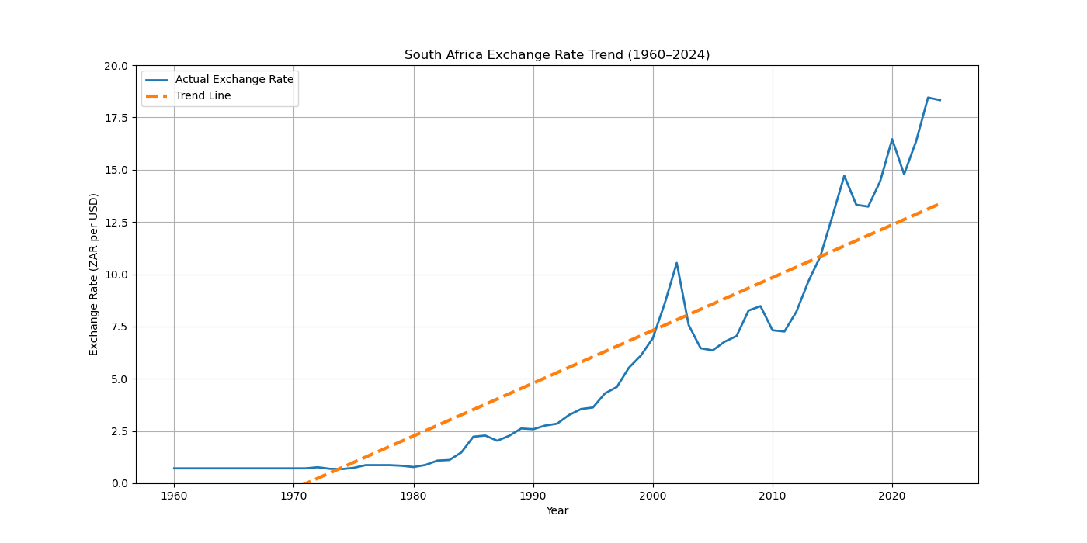
The graph shows a clear upward trend, confirming the regression results that the Rand has depreciated steadily over time.

6. Economic Interpretation
Several macroeconomic factors explain the long-run depreciation trend:
- Inflation Differentials: South Africa has historically experienced higher inflation than the United States, leading to currency depreciation under purchasing power parity theory.
- Trade Deficits: Persistent current account deficits reduce demand for the Rand and increase demand for foreign currency.
- Commodity Dependence: South Africa is heavily dependent on commodity exports, making the Rand vulnerable to global commodity price fluctuations.
- Political and Fiscal Risk: Policy uncertainty, public debt growth, and governance challenges reduce investor confidence and weaken the currency.

7. Phase 4 Extension: Forecasting
To extend the analysis, the trend model was used to forecast future exchange rates for the next ten years. Although simplistic, this provides a baseline forecast and demonstrates applied econometric forecasting skills.
Figure 2: Exchange Rate Forecast (2025–2035)
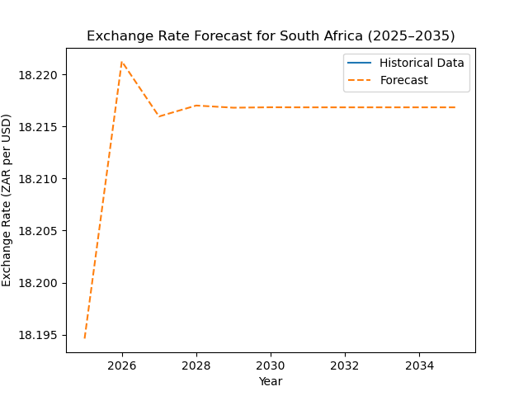
The forecast suggests continued depreciation if historical trends persist. However, future exchange rates will depend on macroeconomic policy reforms, inflation control, and structural economic growth.

8. Conclusion
This project demonstrates the application of Python and econometric techniques to analyse macroeconomic time series data. The results confirm a strong long-run depreciation trend in the South African Rand against the United States Dollar. The study highlights the importance of inflation control, fiscal discipline, and structural reforms in stabilising the currency.
Future research can incorporate advanced models such as Autoregressive Integrated Moving Average models, Vector Autoregression models, and macroeconomic explanatory variables such as interest rates, gross domestic product growth, and inflation.

Appendix A: Python Code
import pandas as pd
import matplotlib.pyplot as plt
from sklearn.linear_model import LinearRegression
import numpy as np

# =============================
# 1. LOAD DATA
# =============================
file_path = "../data/South_Africa_Exchange_Rate.xlsx.xls"
raw_data = pd.read_excel(file_path)

# Fix headers (because your file is messy)
raw_data.columns = raw_data.iloc[1]
raw_data = raw_data.drop([0,1])

# Filter South Africa row
data = raw_data[raw_data["Country Name"] == "South Africa"]

# Convert wide format to long format
data_long = data.melt(id_vars=["Country Name"], var_name="Year", value_name="Exchange_Rate")

# Convert to numeric
data_long["Year"] = pd.to_numeric(data_long["Year"])
data_long["Exchange_Rate"] = pd.to_numeric(data_long["Exchange_Rate"])

# Remove missing values
data_long = data_long.dropna()

print("\nFIRST ROWS OF CLEAN DATA:")
print(data_long.head())

# =============================
# 2. DESCRIPTIVE STATISTICS
# =============================
print("\nDESCRIPTIVE STATISTICS")
print(data_long["Exchange_Rate"].describe())

# =============================
# 3. TREND REGRESSION MODEL
# =============================
# Create time index
data_long["t"] = np.arange(len(data_long))

X = data_long[["t"]]
y = data_long["Exchange_Rate"]

model = LinearRegression()
model.fit(X, y)

# Trend equation
b0 = model.intercept_
b1 = model.coef_[0]

print("\nTREND REGRESSION EQUATION:")
print(f"Exchange Rate = {b1} * t + {b0}")

# Predicted trend
data_long["Trend"] = model.predict(X)

# =============================
# 4. FORECAST 10 YEARS AHEAD
# =============================
future_t = np.arange(len(data_long), len(data_long)+10).reshape(-1,1)
future_years = np.arange(data_long["Year"].max()+1, data_long["Year"].max()+11)
forecast = model.predict(future_t)

forecast_df = pd.DataFrame({
"Year": future_years,
"Forecast_Exchange_Rate": forecast
})

print("\nFORECAST (Next 10 Years)")
print(forecast_df)

# =============================
# 5. GRAPH ACTUAL + TREND + FORECAST
# =============================
plt.figure(figsize=(12,6))
plt.plot(data_long["Year"], data_long["Exchange_Rate"], label="Actual Exchange Rate")
plt.plot(data_long["Year"], data_long["Trend"], linestyle="--", label="Trend Line")
plt.plot(forecast_df["Year"], forecast_df["Forecast_Exchange_Rate"], linestyle=":", label="Forecast")

plt.title("South Africa Exchange Rate (1960–2034)")
plt.xlabel("Year")
plt.ylabel("ZAR per USD")
plt.legend()
plt.grid()

# Save graph
plt.savefig("../output/exchange_rate_project_final.png")
plt.show()

